Appium Notes
Each Android version has different API levels
3.7 Android 2.3 Gingerbread (API 9)
3.7.1 Android 2.3.3 Gingerbread (API 10)
3.8 Android 3.0 Honeycomb (API 11)
3.8.1 Android 3.1 Honeycomb (API 12)
3.8.2 Android 3.2 Honeycomb (API 13)
3.9 Android 4.0 Ice Cream Sandwich (API 14)
3.9.1 Android 4.0.3 Ice Cream Sandwich (API 15)
3.10 Android 4.1 Jelly Bean (API 16)
3.10.1 Android 4.2 Jelly Bean (API 17)
3.10.2 Android 4.3 Jelly Bean (API 18)
3.11 Android 4.4 KitKat (API 19)
3.11.1 Android 4.4W KitKat, with wearable extensions (API 20)
3.12 Android 5.0 Lollipop (API 21)
3.12.1 Android 5.1 Lollipop (API 22)
3.13 Android 6.0 Marshmallow (API 23)
3.14 Android 7.0 Nougat (API 24)
3.14.1 Android 7.1 Nougat (API 25)
3.15 Android 8.0 Oreo (API 26)
3.15.1 Android 8.1.0 Oreo (API 27)
3.16 Android 9 Pie (API 28)
3.17 Android 10 (API 29)

Selendroid supports - Multiple Android target API support (10 to 19)
Appium supports - Android 4.2+: Google's UiAutomator/UiAutomator2 (level 17 - latest)

Appium is not a tool, it's a server which is used by selenium. It's built on Node.js. The main advantage of node.js is that the server doesn't have sleeping time. It has idle time though.
For E.g - To a normal server, if we send 100 requests, it will be executed in 200 seconds, 1 req/ 2 sec, but in node.js all the requests will be processed in just 2 seconds
Selenium sends commands to appium in json format via protocols
Appium uses Ui automator for android and ui automation for ios and communicates with android and apple devices respectively. these are libraries
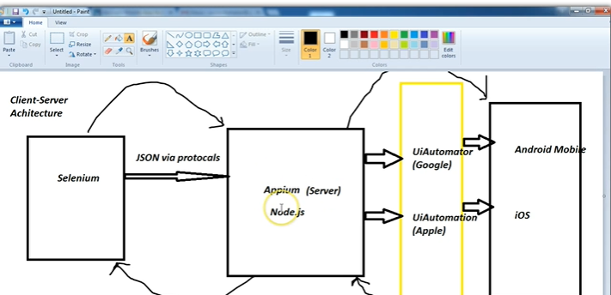
Install Java, Eclipse
Download selenium
2 jars will be downloaded, client combined and client combined src. Just add the libs jars and client combined jars in referenced libraries.
When u click on webdriver and if it says source not found, click attach source and add the client combined src jar, it should work now
Install APK of any app, use ES file explorer to take backup
If we want to install it from a windows machine, connect the mobile to the system and go to cmd and type 'adb devices' - it should show the mobile device and not as offline
then type 'adb install <apk path>' --> this will install the apk in mobile
Use Google chrome Google api extension to download any api directly from Windows (APK Downloader)

Installing Appium
Download the below software
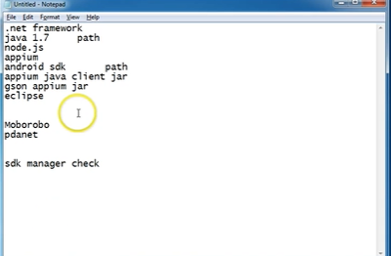
Eclipse communicates to Appium Android SDK Android mobile and Appium also directly communicates to mobile, but the functionality is limited

Keywords:
Download .NET framework 4.5
Appium supports java 1.7>greater -> Java SE Dev kit 8
Install TestNG for eclipse from marketplace
Enable USB Debugging in mobile
Download android sdk path (Android Studio)
Setting Env. Path for android sdk
System variables Android_home SDK folder path
Env. Variables path platform folder path ; platform tools folder path
Connect the mobile to the system, if the mobile is not getting connected use the below software to solve the driver issues
Moborobo
Pdanet

Open android sdk manager sdk manager helps update the libraries for latest api levels
Download Appium from Appium.io
Download Appium jars (client libraries) from appium.io
Download selenium jars rom selenium hq.org
Download gson jar from mvnrepository
Install node.js
Download any apk open Appium and give the path of that apk downloaded
Default port of Appium 4723
In general settings server address provide system’s ip and check prelaunch app and click on launch server

